

Semester One Examination, 2020

Question/Answer booklet

MATHEMATICS METHODS
UNIT 1

Section One:

Calculator-free

Your Name _______________________________

Your Teacher’s Name _____________________________

Time allowed for this section
Reading time before commencing work: five minutes
Working time: fifty minutes

Materials required/recommended for this section
To be provided by the supervisor
This Question/Answer booklet
Formula sheet

To be provided by the candidate
Standard items: pens (blue/black preferred), pencils (including coloured), sharpener, correction fluid/tape, eraser, ruler, highlighters

Special items: nil

Important note to candidates
No other items may be taken into the examination room. It is your responsibility to ensure that you do not have any unauthorised material. If you have any unauthorised material with you, hand it to the supervisor before reading any further.
Question | Marks | Max | Question | Marks | Max
1 |  | 8 | 6 |  | 6
2 |  | 8 | 7 |  | 5
3 |  | 6 | 8 |  | 5
4 |  | 7
5 |  | 5

Structure of this paper

Section | Number of questions available | Number of questions to be answered | Working time (minutes) | Marks available | Percentage of examination
Section One:  Calculator-free | 8 | 8 | 50 | 50 | 33
Section Two:  Calculator-assumed | 13 | 13 | 100 | 100 | 67
 |  |  |  | Total | 100

Instructions to candidates

- The rules for the conduct of the Western Australian Certificate of Education ATAR course examinations are detailed in the Year 12 Information Handbook 2020. Sitting this examination implies that you agree to abide by these rules.

- Write your answers in this Question/Answer booklet.

- You must be careful to confine your answers to the specific questions asked and to follow any instructions that are specific to a particular question.

- Additional pages for the use of planning your answer to a question or continuing your answer to a question have been provided at the end of this Question/Answer booklet. If you use the space to continue an answer, indicate in the original answer space where the answer is continued, i.e. give the page number.

- Show all your working clearly. Your working should be in sufficient detail to allow your answers to be checked readily and for marks to be awarded for reasoning. Incorrect answers given without supporting reasoning cannot be allocated any marks. For any question or part question worth more than two marks, valid working or justification is required to receive full marks. If you repeat any question, ensure that you cancel the answer you do not wish to have marked.

- It is recommended that you do not use pencil, except in diagrams.

- The Formula sheet is not to be handed in with your Question/Answer booklet.

See Next Page

Section One: Calculator-free (50 Marks)

This section has eight (8) questions. Answer all questions. Write your answers in the spaces provided.

Spare pages are included at the end of this booklet. They can be used for planning your responses and/or as additional space if required to continue an answer.
● Planning: If you use the spare pages for planning, indicate this clearly at the top of the page.
● Continuing an answer: If you need to use the space to continue an answer, indicate in the original answer space where the answer is continued, i.e. give the page number. Fill in the number of the question that you are continuing to answer at the top of the page.

Working time: 50 minutes.

Question 1 {1.1.6, 1.1.9} (8 marks)

Solve the following equations.

- $3\left(4x+8\right)=5(3-2x)$ (1 mark)

- $\frac{x-1}{4}-\frac{2x+1}{8}=x$ (2 marks)

- $-{2x}^{2}+8x=1$ by using the quadratic formula (2 marks)

- $x^{2}-6x+6=0$ by completing the square (3 marks)

Question 2 {1.1.2, 1.1.11} (8 marks)
- Point A is the intersection of lines $2x+y-4=0$ and $2y=-5x+11$. Point M (10,18) is the mid-point of Point A and Point B (a, b). Determine the values of a and b.
(3 marks)

- A parabola has $x$-axis intercepts ($3, 0)$ and $(-5, 0)$ and it passes through the point $(4, 18)$. Find the turning point of this parabola.
(2 marks)

- A quadratic function has equation $y=3x^{2}+27x-108$. Find the coordinates of the x-intercepts.
(2 marks)

- Three quadratic functions $f\left(x\right)=9x^{2}-6x+1$, $g\left(x\right)={-x}^{2}-5x-6$ and
$h\left(x\right)=x^{2}+\frac{1}{2}x+1$. Underneath each function in the table below, write the number of real solution(s).
(1 mark)

Function | $$f\left(x\right)$$ | $$g\left(x\right)$$ | $$h\left(x\right)$$
Number of Solution(s)

Question 3 {1.1.22} (6 marks)
The graph of the relation ${(y-1)}^{2}=2x$ passes through the points ($p$, 3) and (8,$q$).
- Determine the values of $p$ and $q$.
(3 marks)

- On the axes below, sketch the graph of the relation, labelling all key features with their coordinates or equation.
(3 marks)

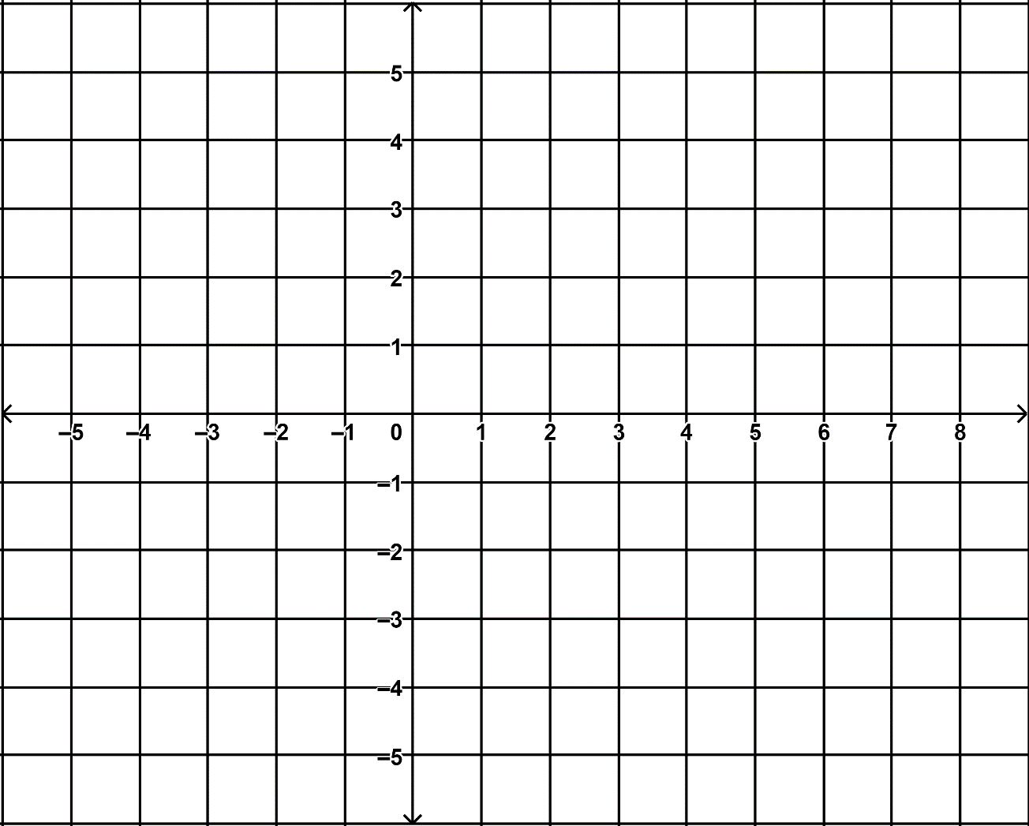

Question 4 {1.1.21, 1.1.28} (7 marks)
Consider the given graph below.

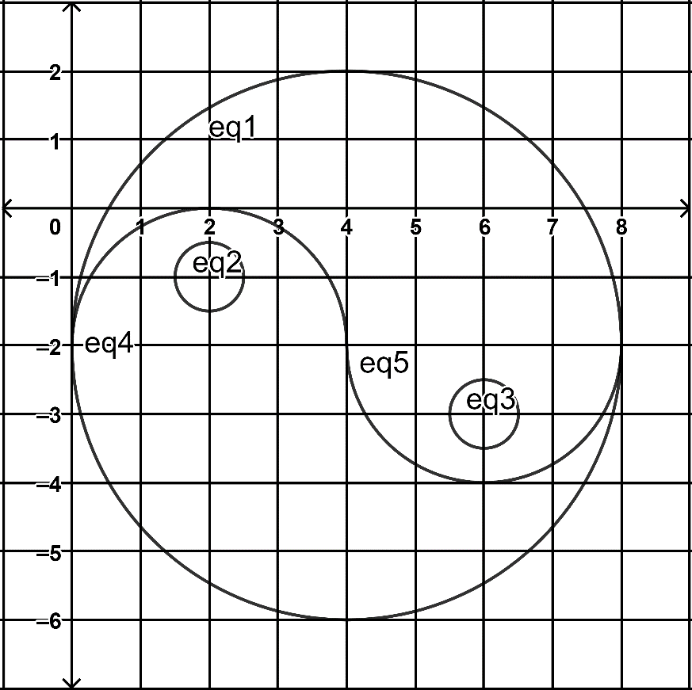

- Determine the equations of all the curves forming the shapes in the graph.
(5 marks)

- List all the functions in the graph. Justify your answers. (2 marks)

Question 5 {1.1.16, 1.1.17} (5 marks)
- Given that ${-6x}^{3}-13x^{2}+14x-3=(x+3)({bx}^{2}+cx-1)$ for all values of $x$, for suitable values of $b$ and $c$. Find $b$ and $c$ by equating coefficients.
(2 marks)

- Consider the graph of polynomial $P(x)$ below. Determine the equation in the form $P\left(x\right)=a_{n}x^{n}+a_{n-1}x^{n-1}+ ∙ ∙ ∙ +{ a}_{1}x+a_{0}$. (3 marks)

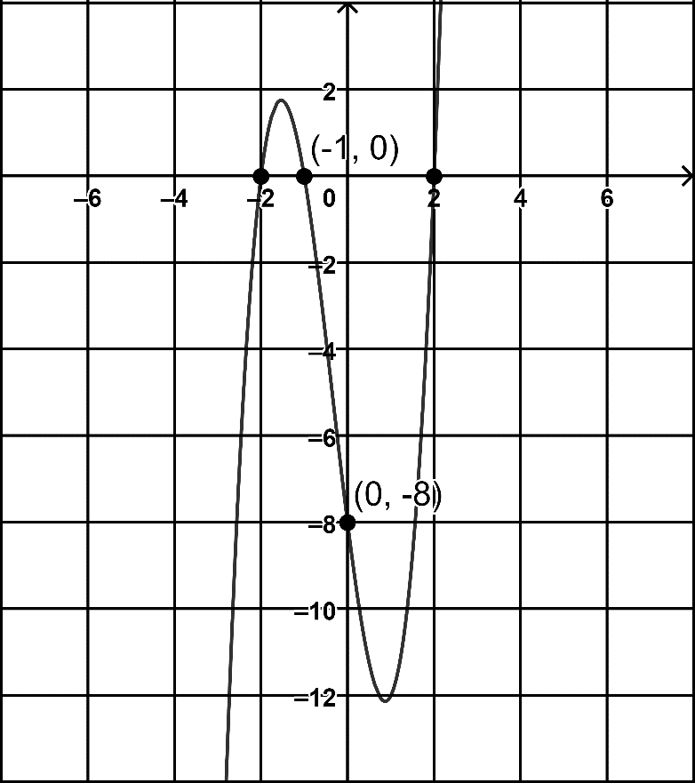

Question 6 {1.1.24, 1.1.25} (6 marks)
- State the natural/implied domain and range for each of the relations/functions below.
(3 marks)

Relation/Function | Natural Domain | Natural Range
$$y=\sqrt{x-3}+5$$

$$y=\frac{4}{2x+3}-5$$

$${(x+1)}^{2}+{(y-2)}^{2}=9$$

- Sketch the graph of the function, $f:\left[-6, 2\right]→R, f\left(x\right)=\frac{1}{2}x^{2}+2x+3$, and state its range. (3 marks)

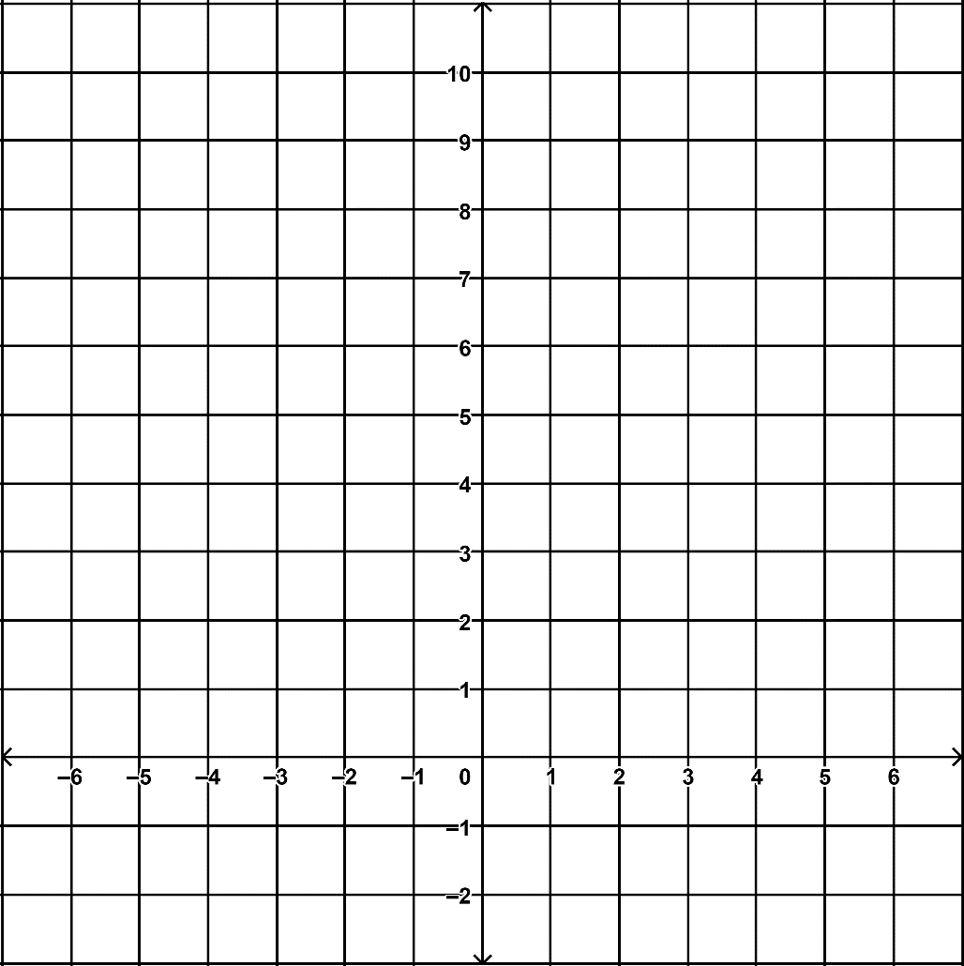

Question 7 {1.4.14} (5 marks)
A and B are independent events. $P\left(A∪B\right)=0.64$ and $P\left(A | B\right)=0.4$. Determine $P\left(B\right).$

Question 8 {1.1.19} (5 marks)
Let $P\left(x\right)=x^{3}+kx^{2}-\left(k+3\right)x-2k-2$

- Show that $P\left(x\right)$ is divisible by $x+1$. (1 mark)

- Factorise $P\left(x\right)$ fully. (4 marks)

END OF SECTION ONE
Additional working space
Question number:

Additional working space
Question number:

